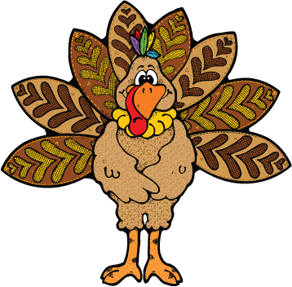

Run, Walk or Skip to get your blood pumping before the Thanksgiving Day feast! Join us for our 8th annual, 1 mile FREE family Turkey Trot. Every Grant Watts student who participates will earn a Turkey Trot token which will be delivered at school with the rest of their Walks A Lot tokens.

To register: please fill out and return the form on the back to the office. Turkey Trot T-shirts are available for purchase return order form below by November 10th 2017

**NO PETS PLEASE.**

**Thanksgiving Day!**

**Thursday November 23th 2017, 9:30 AM**

**At the Grant Watts Elementary playground.**

********************************T-shirt Order Form*******************************

Student name_______________________________________________

Parent/Guardian name________________________________________________

Teacher________________________________

Phone #____________________________

Adult Size: XXL ___ XL ___ L___ M___ S___

Youth Size: XL___ L___ M___ S___ XS___

**Shirt cost is $10.00 each, $ 2.00 extra for adult XXL. Please make checks out to GWPO, cash OK too. Shirt will be available for pick-up the morning of the Turkey Trot. Please fill out, sign and return the Liability and Release form on the back to the office, if ordering a shirt please return by the 10th of November. Hope to see you there!**

**Turkey Trot Time !!**